4.3.1 Logic Diagrams
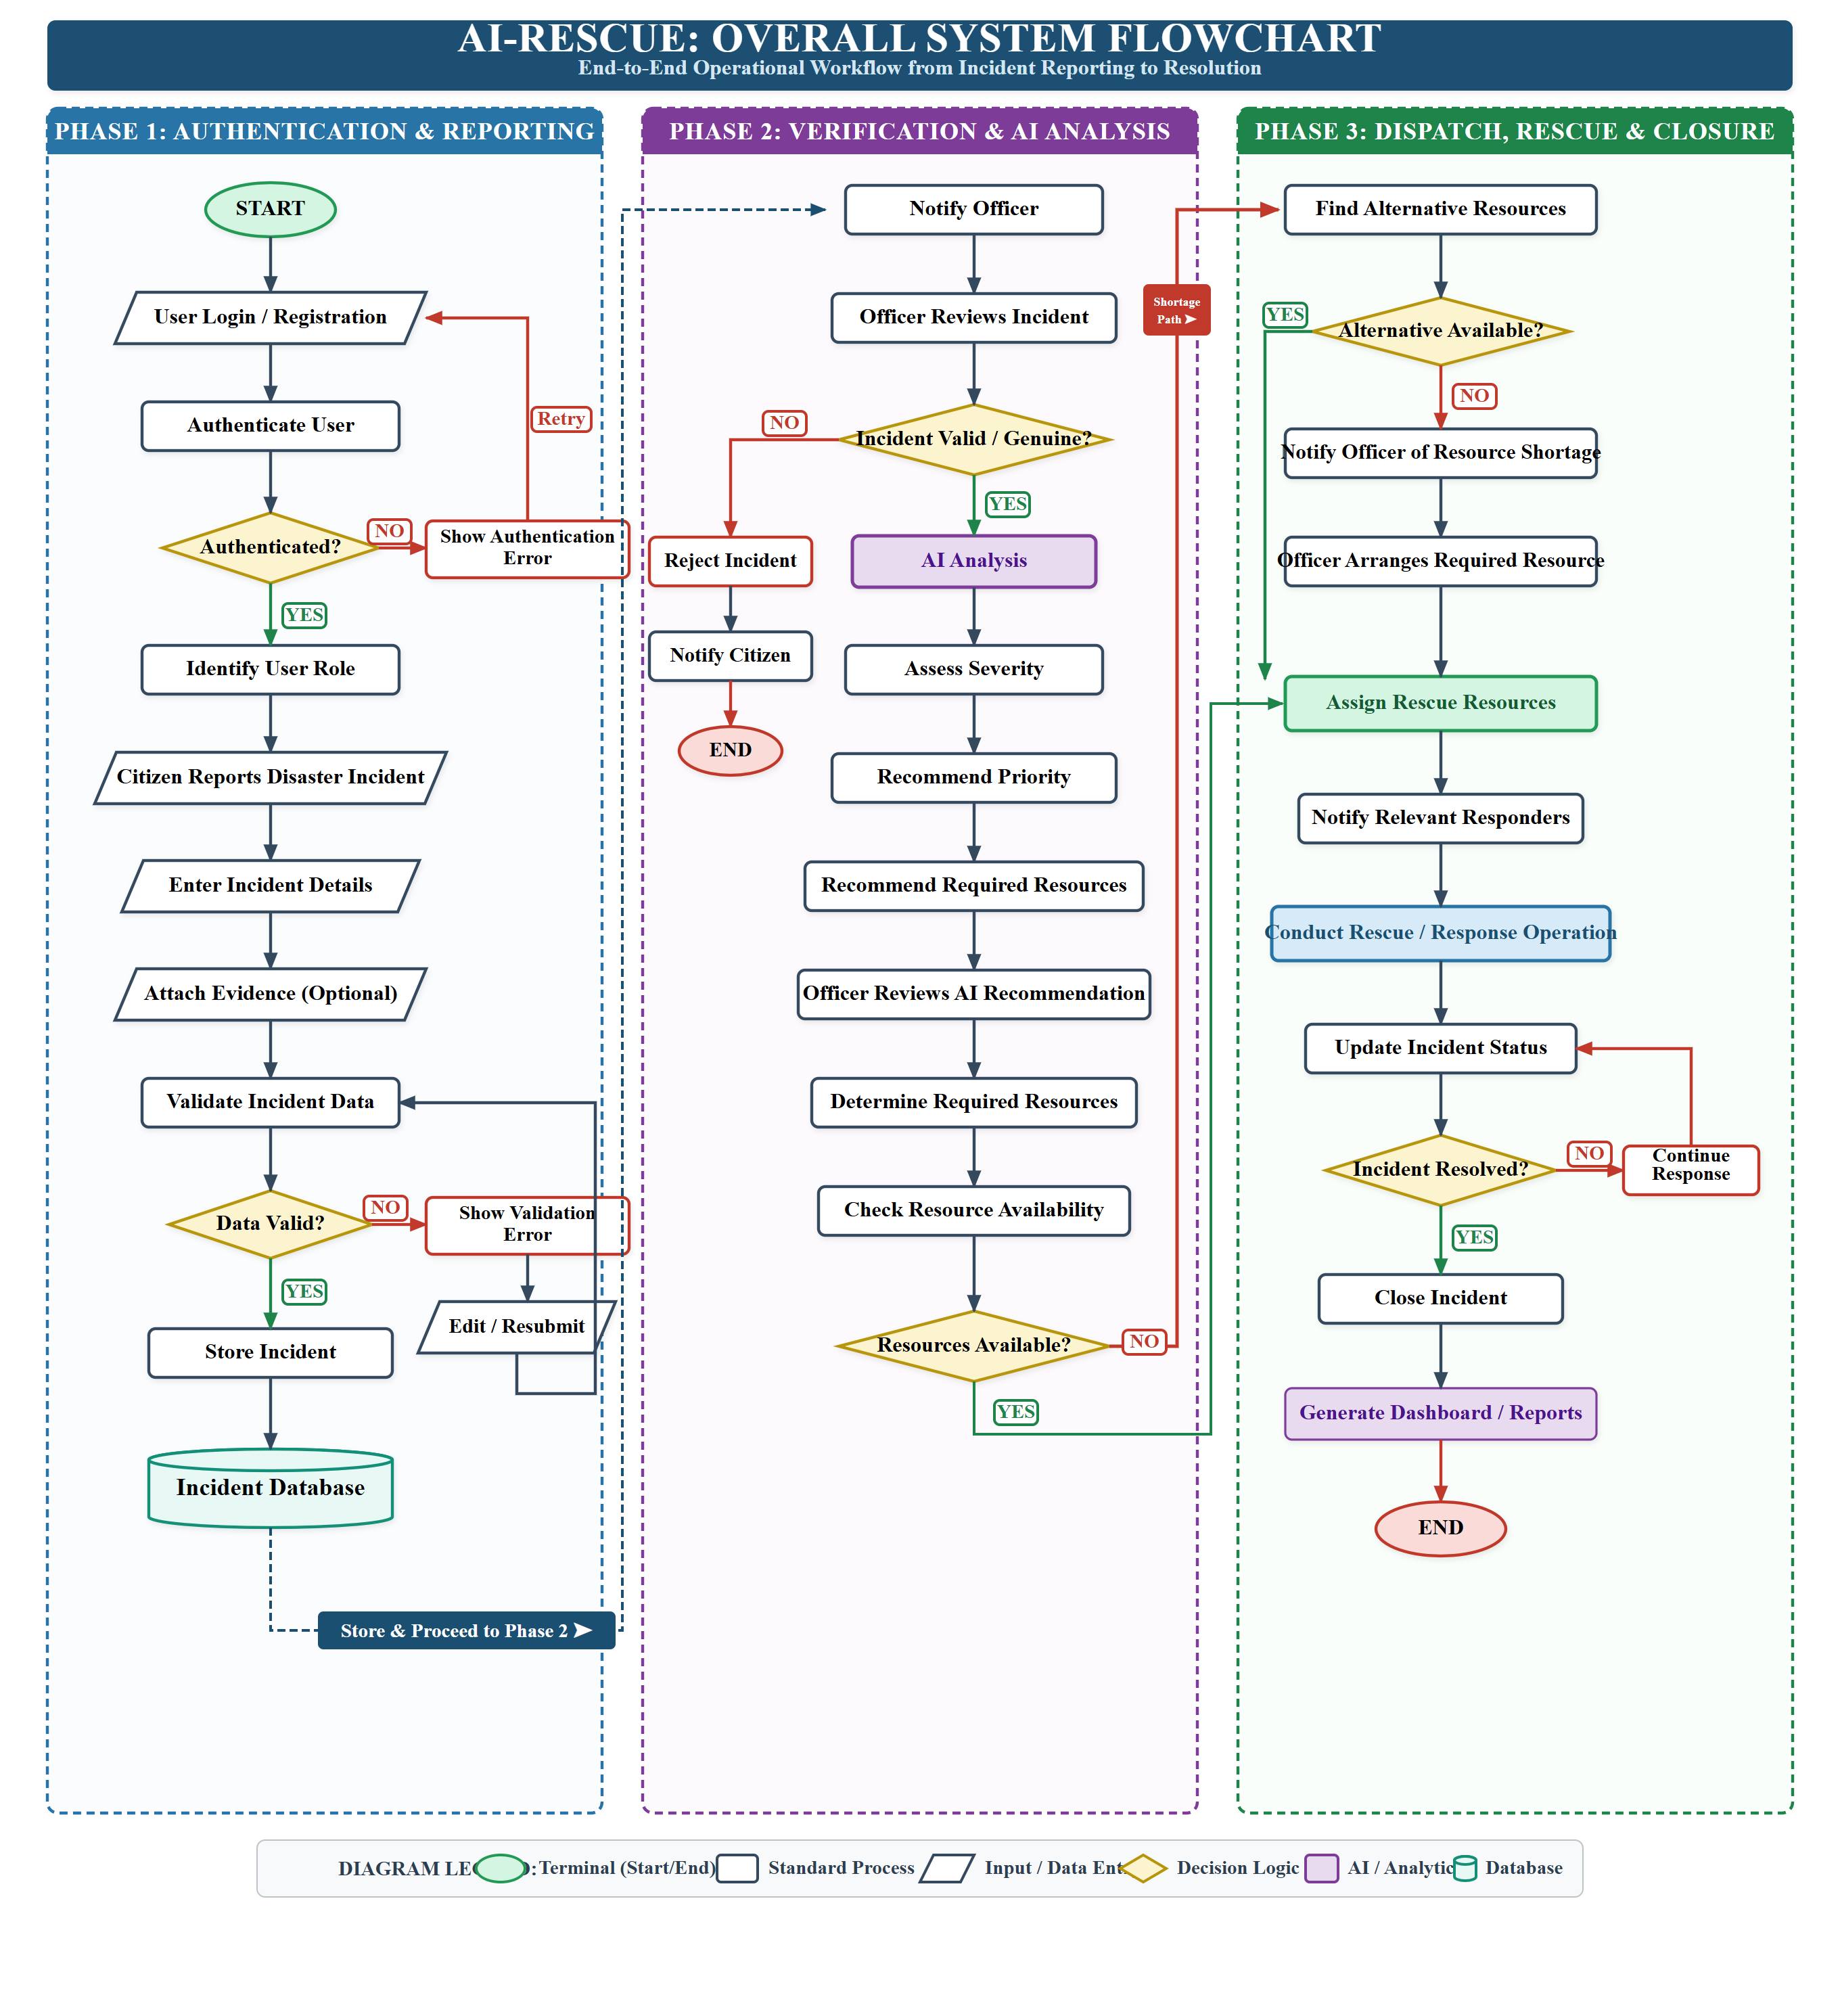
Figure 4.3: Overall System Flowchart
The overall system flowchart represents the complete operational workflow of the AI-Rescue platform, from incident reporting to incident resolution.
The workflow includes authentication, incident reporting, validation, officer verification, AI-assisted analysis, resource allocation, emergency response, status updates, and incident closure.

CHAPTER 4: SYSTEM DESIGN
4.1 Basic Modules
The AI-Rescue platform is divided into functional modules. Each module is responsible for a specific set of operations while communicating with other modules through the application's backend.
4.1.1 User Authentication and Role Management
This module manages user registration, login, authentication, and role-based access.
Main functions:
- User registration.
- User login.
- Credential verification.
- Role identification.
- Session management.
- Access control.
- Account status management.
The system provides different permissions according to the user's role.
Related tables:
- ROLE
- USER

4.1.2 Disaster Incident Management
This is the central operational module of the system.
It allows users to report disaster incidents and allows authorized officers to review and manage them.
Main functions:
- Create incident reports.
- Enter disaster details.
- Record incident location.
- Record affected population.
- Attach supporting evidence.
- Validate incident information.
- Review submitted incidents.
- Verify or reject incidents.
- Update incident status.
- Close resolved incidents.
Related tables:
- DISASTER_TYPE
- INCIDENT
- INCIDENT_MEDIA
- USER

4.1.3 AI Decision-Support Module
The AI module assists authorized officers in evaluating verified disaster incidents.
The AI module is not responsible for independently approving incidents or dispatching emergency resources.
The workflow is:
Incident Report
↓
Officer Verification
↓
Verified Incident
↓
AI Analysis
↓
Severity Assessment
↓
Priority Recommendation
↓
Resource Recommendation
↓
Officer Review
↓
Operational Decision
The module may generate:
- Severity score.
- Priority recommendation.
- Recommended resource types.
- Confidence score.
- Reasoning/explanation associated with the recommendation.
Related table:
- AI_RECOMMENDATION

4.1.4 Resource Management Module
This module manages the emergency resources available to the organization.
Resources can include general response resources, vehicles, and equipment.
Main functions:
- Add resources.
- Update resource information.
- View resource availability.
- Track resource status.
- Manage vehicles.
- Manage equipment.
- Assign resources to incidents.
Related tables:
- RESOURCE
- VEHICLE
- EQUIPMENT
- RESOURCE_ASSIGNMENT

4.1.5 Resource Assignment and Coordination Module
This module connects verified incidents with the resources required for response.
After the officer reviews the AI recommendation, the system checks available resources.
Verified Incident
↓
AI Recommendation
↓
Officer Review
↓
Determine Required Resources
↓
Check Availability
↓
Resources Available?
/ \
YES NO
↓ ↓
Assign Find Alternative /
Resources Escalate Requirement
↓ ↓
└──────→ Response Planning
If suitable resources are unavailable, the system can record the requirement for alternative resources or escalation to a higher-level authority/support mechanism.
Related tables:
- RESOURCE
- VEHICLE
- EQUIPMENT
- RESOURCE_ASSIGNMENT
- USER

4.1.6 Hospital Management Module
This module maintains information about hospitals that may be relevant during emergency response.
The information may include:
- Hospital name.
- Address.
- Location.
- Contact number.
- Emergency capacity.
- Available beds.
- Current status.
The module helps authorized users identify hospital capacity when emergency medical support is required.
Related table:
- HOSPITAL

4.1.7 Shelter Management Module
This module manages emergency shelter information.
The information may include:
- Shelter name.
- Address.
- Location.
- Contact number.
- Total capacity.
- Current occupancy.
- Availability/status.
The information can support decisions regarding temporary accommodation for affected populations.
Related table:
- SHELTER

4.1.8 Notification Module
The notification module manages communication of important system events to relevant users.
Notifications can be generated for events such as:
- New incident submission.
- Incident verification.
- Incident rejection.
- Resource assignment.
- Response updates.
- Other important operational events.
Related tables:
- NOTIFICATION
- USER
- INCIDENT

4.1.9 Dashboard and Reporting Module
The dashboard provides an overview of disaster-response activities.
Possible information displayed includes:
- Total incidents.
- Active incidents.
- Incident priority.
- Incident status.
- Resource availability.
- Response activities.
- Notifications.
- Summary statistics.
The reporting component allows authorized users to generate reports based on stored system information.
Related tables:
- REPORT_LOG
- INCIDENT
- RESOURCE
- RESOURCE_ASSIGNMENT

4.1.10 Audit and System Administration Module
This module provides administrative control and system traceability.
The audit component records important actions performed within the system.
Examples include:
- User-related changes.
- Incident modifications.
- Resource assignments.
- Administrative actions.
- Configuration changes.
The administrator can also manage system-level settings.
Related tables:
- AUDIT_LOG
- SYSTEM_SETTINGS
- USER

4.2 Data Design
Data design defines how information is organized, stored, related, and protected within the AI-Rescue platform.
The proposed system uses a relational database model with PostgreSQL.
The finalized V1 database consists of 16 tables.
These tables are organized into the following logical groups:

4.2.1 Schema Design
1. ER DIAGRAM

Figure 4.1: Entity Relationship Diagram of AI-Rescue

1. ROLE
Stores the roles available within the system.

2. USER
Stores registered users and their role information. In the physical PostgreSQL implementation, this entity is mapped to the table named 'users' to avoid collision with the PostgreSQL reserved system keyword.

3. DISASTER_TYPE
Stores the different types of disasters supported by the system.

4. INCIDENT
Stores the main disaster incident information.

5. INCIDENT_MEDIA
Stores evidence associated with an incident.

6. AI_RECOMMENDATION
Stores the algorithmic assessments generated by the AI decision-support engine, including severity scores, priority ratings, recommended assets, and human-in-the-loop verification attributes (review_status, reviewed_by, reviewed_at) to guarantee operational oversight.

7. RESOURCE
Stores general emergency resources.

8. VEHICLE
Stores emergency-response vehicles.

9. EQUIPMENT
Stores emergency equipment.

10. RESOURCE_ASSIGNMENT
Stores the operational allocation of relief assets to active disaster incidents, tracking the exact quantity_assigned and linking directly to either a resource, vehicle, or equipment entity.

11. HOSPITAL
Stores emergency hospital information.

12. SHELTER
Stores emergency shelter information.

13. NOTIFICATION
Stores notifications generated by the system.

14. REPORT_LOG
Stores information about generated reports.

15. AUDIT_LOG
Stores records of important system activities.

16. SYSTEM_SETTINGS
Stores configurable system settings.

2. Database Design

Figure 4.2: Database Design of AI-Rescue
The database design represents the relational structure of the AI-Rescue platform. The system uses 16 tables to store and manage operational data.
The database contains tables for user management, incidents, AI recommendations, resources, emergency facilities, notifications, reporting, auditing, and system configuration. Primary and foreign keys maintain relationships and data integrity.

4.2.2 Data Integrity and Constraints
Data integrity ensures that the information stored in the database remains accurate, consistent, and reliable.
The following constraints are considered in the database design.
Primary Key
Every table contains a unique primary key that identifies each record.
For example:
USER.user_id
INCIDENT.incident_id
RESOURCE.resource_id
HOSPITAL.hospital_id
Foreign Key
Foreign keys maintain relationships between related tables.
For example:
USER.role_id
↓
ROLE.role_id
and:
INCIDENT.disaster_type_id
↓
DISASTER_TYPE.disaster_type_id
NOT NULL
Important attributes should not be allowed to contain empty values.
For example, a user account should require essential information such as name, email, and password.
UNIQUE
Attributes such as email addresses can be restricted to unique values where required.
CHECK Constraints
Appropriate operational values and business invariants are enforced at the database engine level using PostgreSQL check constraints. For example:
For example:
people_affected >= 0
quantity_available >= 0
available_beds >= 0
current_occupancy >= 0
Referential Integrity
Foreign-key relationships prevent invalid references between related records.
Transaction Integrity
Database transactions can be used when multiple related operations must either complete successfully together or be rolled back.

4.3 Procedural Design
Procedural design describes the logical procedures followed by the system when processing different operations.
The major procedures include:
- User authentication.
- Incident reporting.
- Incident verification.
- AI analysis.
- Resource availability checking.
- Resource assignment.
- Incident response and status management.
- Notification processing.
- Report generation.

Figure 4.4: User Authentication Module Flowchart

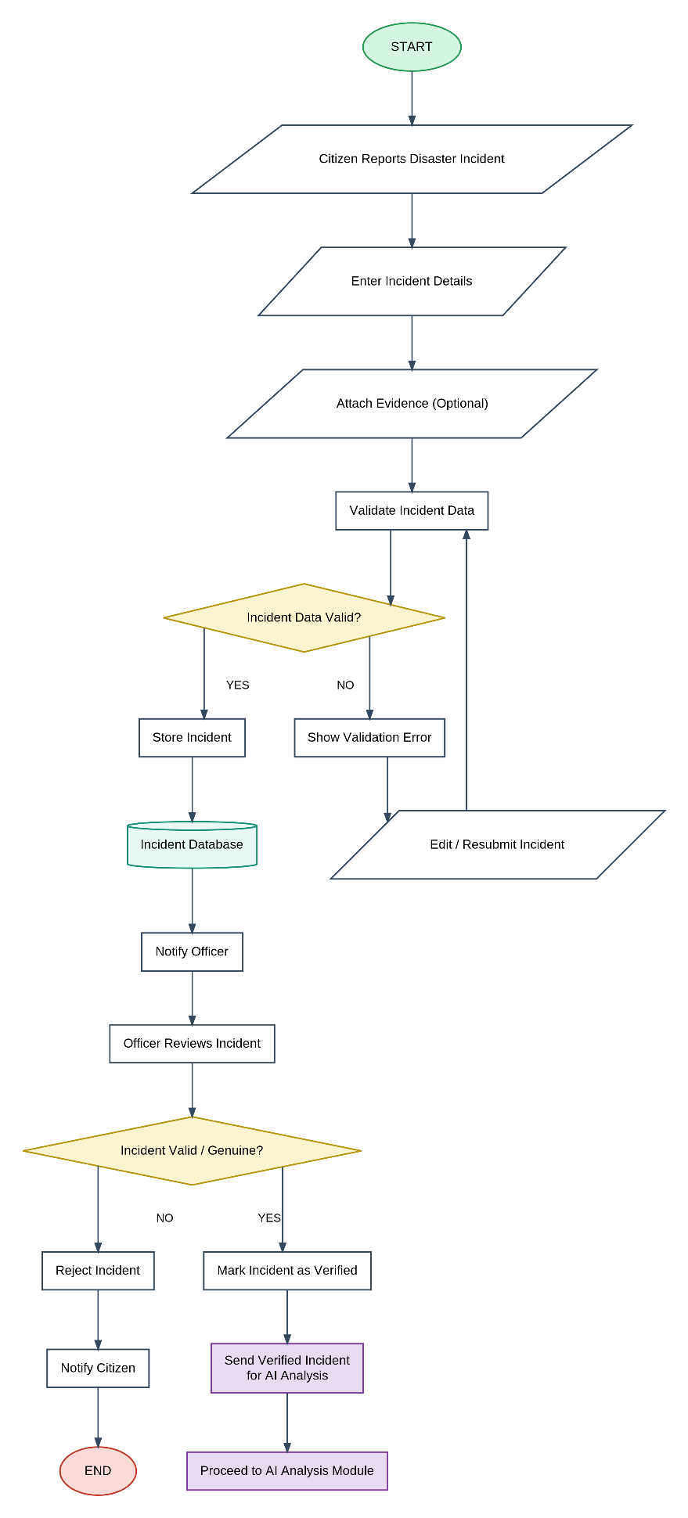
Figure 4.5: Incident Reporting Flowchart

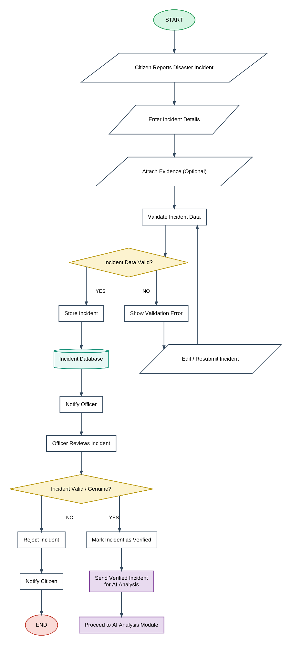
Figure 4.6: AI Analysis Flowchart

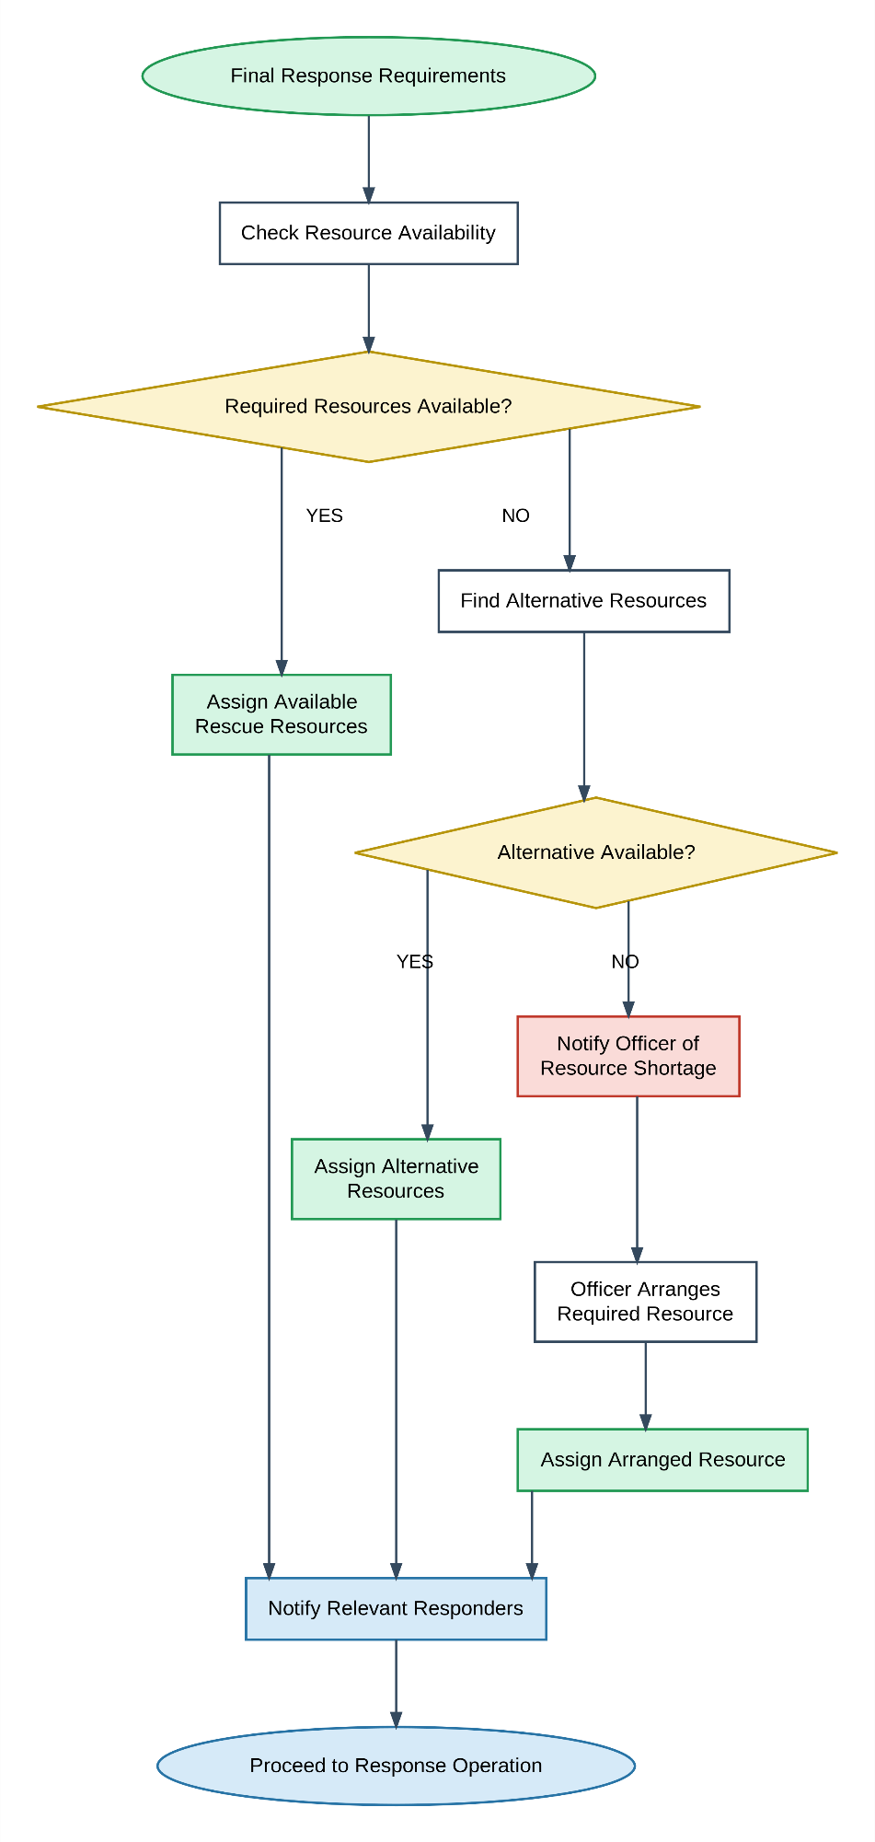

Figure 4.7: Resource Management and Assignment Module Flowchart

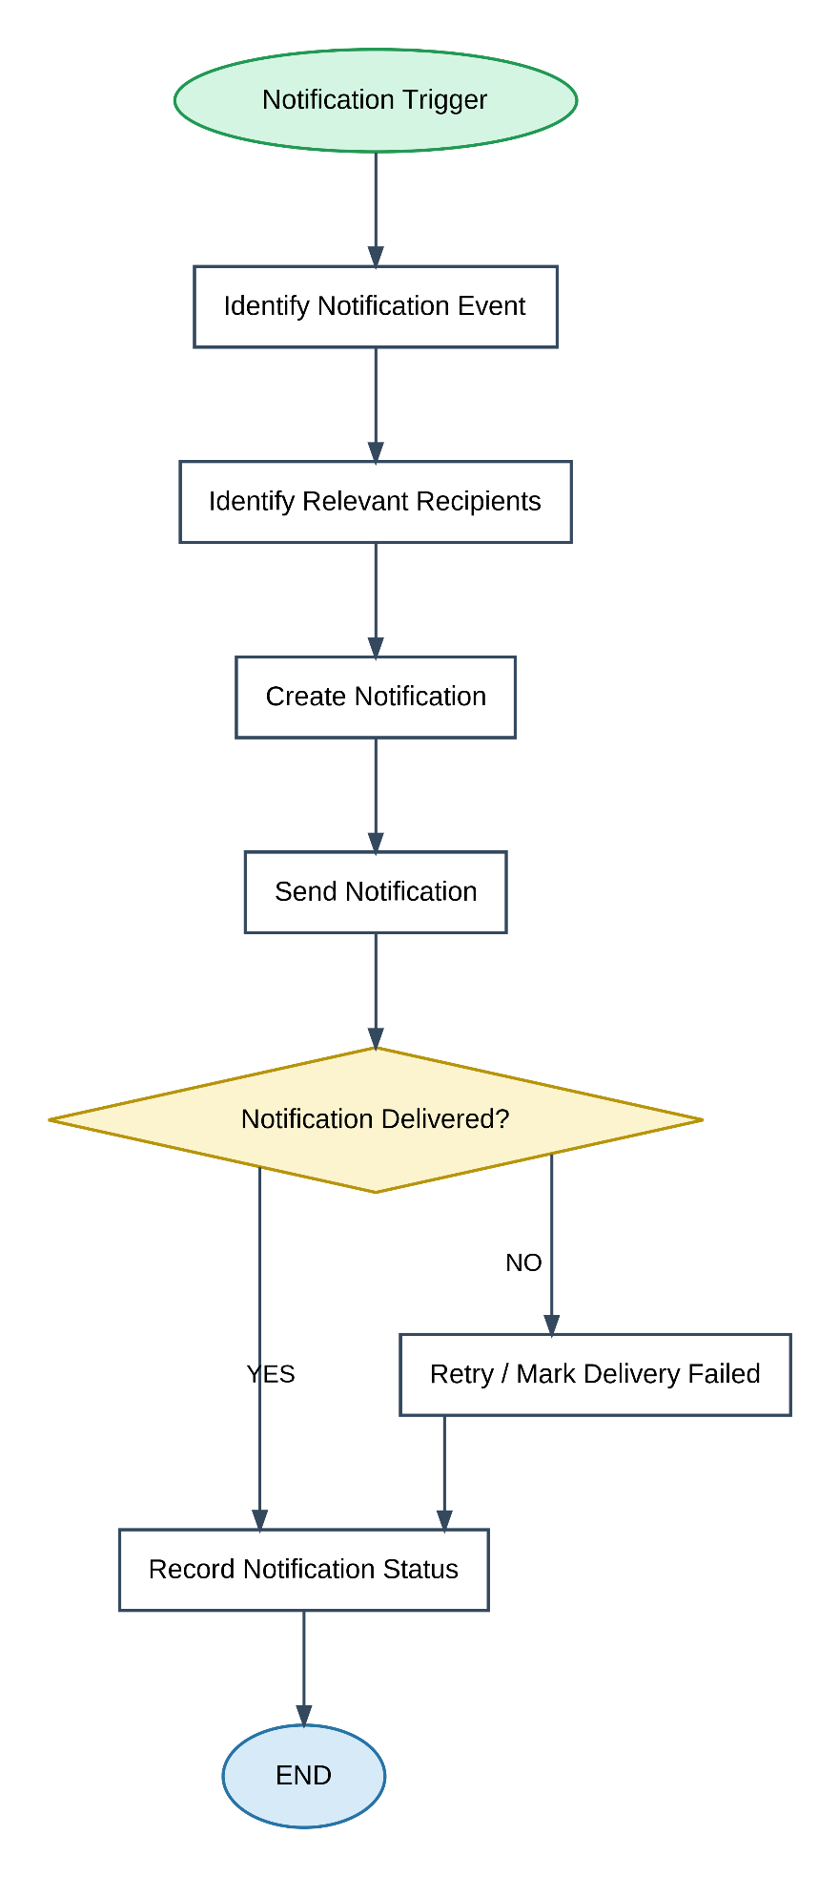
Figure 4.8: Notification Module Flowchart

7. Sequence Diagram
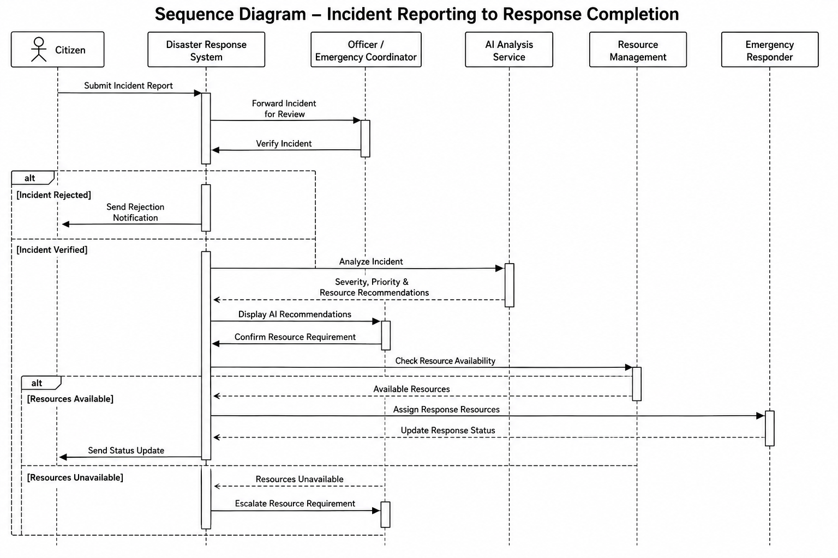
The Sequence Diagram models the chronological procedural interactions and message exchanges across system lifelines during an end-to-end disaster response scenario. The sequence illustrates the strict Human-in-the-Loop workflow: a citizen submits an emergency incident report, which is routed to an Emergency Coordinator for initial verification. Upon confirmation, the verified incident triggers the AI Analysis Service to estimate severity and recommend suitable response assets. The officer reviews and confirms the AI recommendations, prompting the system to verify resource availability and dispatch assigned emergency personnel and vehicles, followed by automated citizen status notifications.

Figure 4.9: Sequence Diagram – Incident Reporting to Response Completion
4.3.2 Data Structures
The system uses several logical data structures during processing.
User Object
User
├── user_id
├── role_id
├── full_name
├── email
├── phone
└── status
Incident Object
Incident
├── incident_id
├── disaster_type_id
├── reported_by
├── location
├── severity
├── priority
├── people_affected
└── status
AI Recommendation Object
AI Recommendation
├── recommendation_id
├── incident_id
├── severity_score
├── priority_level
├── recommended_resources
└── confidence_score
Resource Assignment Object
Resource Assignment
├── assignment_id
├── incident_id
├── resource_id
├── vehicle_id
├── equipment_id
├── assigned_by
└── status
These structures represent the logical information handled by the application before or during database operations.

4.3.3 Algorithms Design
Algorithm 1: User Authentication
Step 1: Accept email and password.
Step 2: Validate the entered credentials.
Step 3: Search for the corresponding user account.
Step 4: Verify the password against the stored password hash.
Step 5: Check account status.
Step 6: If valid, create an authenticated session/token.
Step 7: Identify the user's role.
Step 8: Provide access according to the assigned role.
Step 9: Otherwise, display an authentication error.

Algorithm 2: Incident Verification
Step 1: Receive submitted incident.
Step 2: Display incident information to authorized officer.
Step 3: Officer reviews incident details and evidence.
Step 4: Determine whether the incident is genuine.
Step 5: If invalid:
Reject incident.
Update incident status.
Notify citizen.
Step 6: If valid:
Mark incident as verified.
Record verification details.
Send incident for AI analysis.

Algorithm 3: AI-Assisted Incident Analysis
Step 1: Receive verified incident data.
Step 2: Prepare relevant input attributes.
Step 3: Send the data to the AI service.
Step 4: AI processes the incident information.
Step 5: Calculate/estimate severity.
Step 6: Generate priority recommendation.
Step 7: Generate required-resource recommendation.
Step 8: Calculate confidence score.
Step 9: Return recommendation to the backend.
Step 10: Store the recommendation.
Step 11: Present the recommendation to the authorized officer.

Algorithm 4: Resource Availability and Assignment
Step 1: Receive verified incident and required resource information.
Step 2: Check available resources.
Step 3: Check vehicle availability.
Step 4: Check equipment availability.
Step 5: If suitable resources are available:
Select appropriate resources.
Create resource assignment.
Update resource status.
Notify relevant responders.
Step 6: If required resources are unavailable:
Identify possible alternatives.
Record the unmet requirement.
Escalate the requirement when necessary.
Step 7: Continue response planning.

4.4 User Interface Design
The user interface is designed to provide a simple and role-specific experience.
4.4.1 Login Page
The login interface provides:
- Email/username input.
- Password input.
- Login button.
- Registration option.
- Error messages.

4.4.2 Citizen Dashboard
The citizen dashboard can provide:
- Report disaster button.
- Submitted incidents.
- Incident status.
- Notifications.
- Profile information.

4.4.3 Officer Dashboard
The officer dashboard provides access to operational information such as:
- New incidents.
- Pending verification.
- Verified incidents.
- AI recommendations.
- Resource availability.
- Active responses.
- Notifications.
- Reports.

4.4.4 Administrator Dashboard
The administrator interface provides:
- User management.
- Role management.
- Resource management.
- System settings.
- Audit records.
- Reports.

4.4.5 Incident Reporting Interface
The incident reporting form can contain:
- Disaster type.
- Incident title.
- Description.
- Location.
- Geographic coordinates.
- People affected.
- Supporting evidence.
- Submit button.
The interface should clearly indicate mandatory and optional fields.

4.5 Security Issues
Because the platform handles user information and potentially sensitive disaster-response information, security is an important part of the system design.
4.5.1 Authentication
Users must authenticate before accessing protected functionality.
4.5.2 Password Security
Passwords should not be stored as plain text. Passwords should be stored using secure password hashing mechanisms.
4.5.3 Role-Based Access Control
Users should only access functions permitted by their roles.
For example:
Citizen
↓
Incident Reporting

Officer
↓
Incident Verification
AI Recommendation Review
Resource Assignment

Administrator
↓
System Management

4.5.4 Authorization
Authentication confirms who the user is, while authorization determines what the user is allowed to do.
4.5.5 Input Validation
User input should be validated to reduce invalid data and common security risks.
4.5.6 Secure Communication
Communication between clients and servers should use HTTPS in the deployed system.
4.5.7 Audit Logging
Important actions should be recorded so that system activities can be traced.
4.5.8 Database Security
Database credentials should be protected, and application users should receive only the permissions required for their operations.

4.6 Test Cases Design
Testing is required to verify that the system behaves according to its functional requirements.
The following test cases represent the major V1 functionality.

